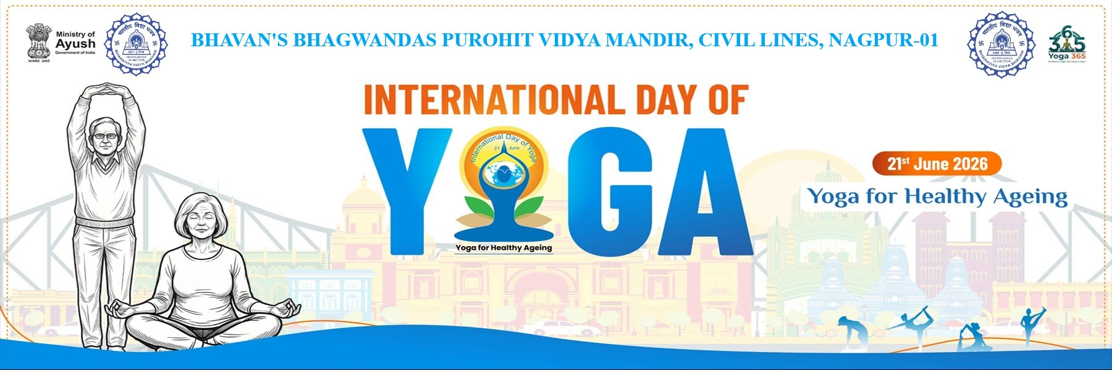

REPORT ON INTERNATIONAL YOGA DAY CELEBRATION
Institution: Bhavan's Bhagwandas Purohit Vidya Mandir, Civil Lines, Nagpur-01
Date of Event: June 21, 2026
Event Title: International Day of Yoga (IDY 2026)
Theme: Yoga for Healthy Ageing
Bhavan's Bhagwandas Purohit Vidya Mandir, Civil Lines, Nagpur, celebrated the 12th International Day of Yoga (IDY 2026) on June 21, 2026. Aligned with the global focus on holistic wellness, the central theme for this year's celebration was "Yoga for Healthy Ageing." The event brought together teachers and staff members to promote physical health, mental clarity, and lifetime fitness habits through a structured morning yoga session.
The morning's proceedings began with a formal opening ceremony to set a serene and respectful tone for the day. The event commenced promptly at 8:00 AM with the arrival of the Respected Principal Madam Smt. Leena Varghese.
The traditional lighting of the lamp took place, symbolizing the enlightenment, knowledge, and harmony that yoga brings to life. A peaceful opening prayer was offered as prescribed in common yoga protocol by the Ministry of AYUSH, to prepare the minds of participants.
The practical segment of the celebration followed a meticulously timed routine, guiding the attendees through various progressive stages of practice which included Sukshma Vyayam, Standing Asanas, Sitting Asanas, Lying Down Asanas, Pranayama and Dhyana.
The mass gathering participated in the collective chanting of the Shanti Path, radiating wishes of peace, health, and harmony to the universe.
A formal vote of thanks was proposed by Smt. Dheeraj Khare, expressing deep gratitude to the school management, Principal Madam Smt. Leena Varghese, physical education teachers and the enthusiastic participants who made the IDY 2026 celebration an impactful success. The overall Incharge of the event was Shri. Washington Gomez.
Through this event, Bhavan's Bhagwandas Purohit Vidya Mandir successfully reinforced the vital message that incorporating regular yoga practice can significantly contribute toward a long, mindful, and healthy life.

